BANCO DE PREGUNTAS- TERCER TRIMESTRE

APELLIDOS Y NOMBRES: …………………………………………………………………….

CURSO: ……………………………………………..FECHA: ….……/………… /2025
MATERIA:………………………………………………………… NOTA:


1.Read and tick T (true) or F (false).

My friends are the best. They have many talents…
Thomas is the best at outdoor activities, he can roller-skate, he can ride a bike or a motorcycle. But when he was 8 years old, he couldn't roller-skate.
Ben is “the musician”. He can play any instrument. He can play the flute, the piano, the trumpet and the violin. When he was 5 years old, he could play the piano and the violin, but he couldn't play the trumpet or the flute.
My friend Constanza is a genius with technology. She can build robots and make them walk. She can program different things on the computer, but she can't design web pages.
 |  | T | F
1. | Thomas can play instruments.
2. | Thomas could roller-skate when he was 8 years old.
3. | When Ben was 5 years old, he could play the trumpet and the flute.
4. | Ben could play the piano when he was a child.
5. | Ben can't play the piano or the flute.
6. | Constanza can't design web pages.

2.Read and complete with “can” or “could”.
- When I was a child, I swim very well.
- I love games, web pages and the Internet, I design web pages.
- Last year, my sister play piano very well.
- When my dad was a child, he roller-skate.
- My best friend loves maths, she solve maths problems perfectly.
- When my brother was 8 years old, he ride a bike.

3. Answer these questions about you.
- Could you roller-skate when you were 6 years old?
- Could you play an instrument when you were 8 years old?
- Can you solve maths problems quickly?
- Can you design web pages?

4.Use words from each box to label the pictures with the correct action.
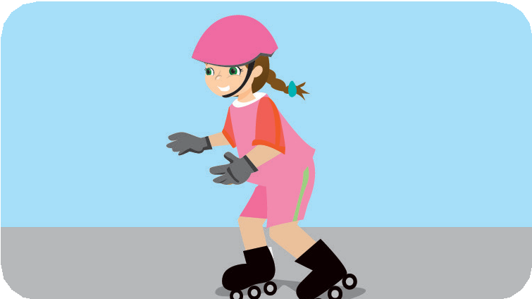
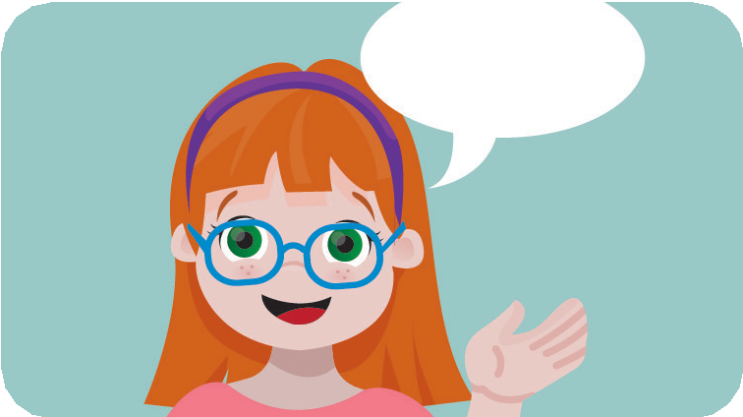
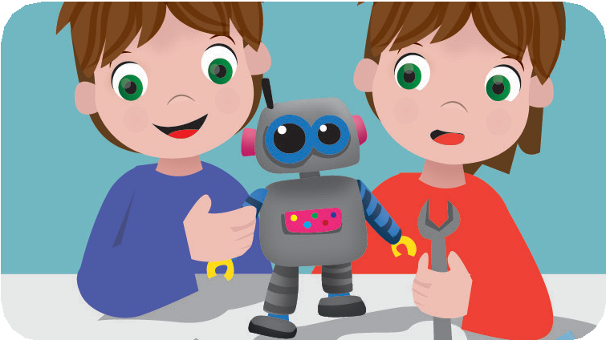

play – speak build – write roller – play
Hello!
- …………………….. 2………………………… 3. …………………………..
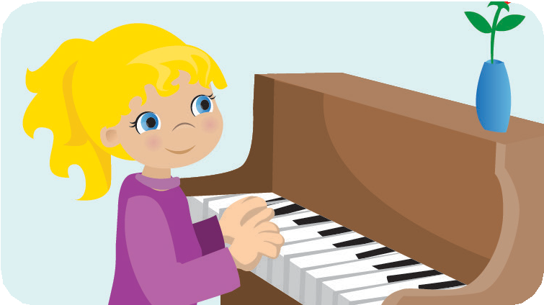
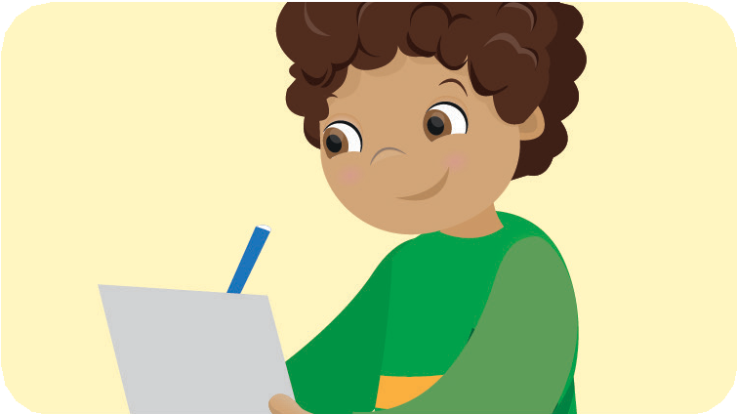
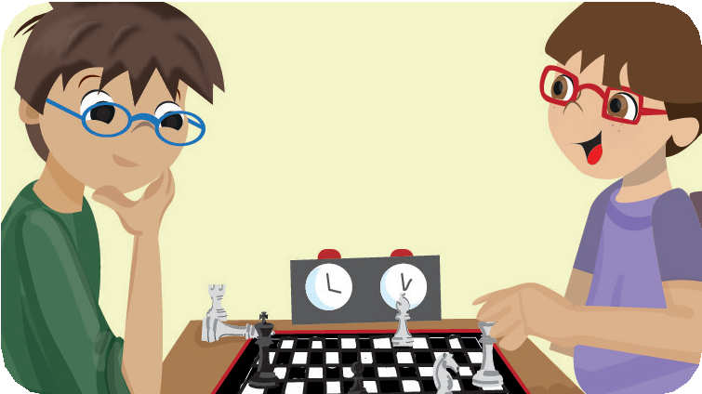

stories – chess skate – English music – robots

4. ……………………… 5. …………………………. 6. ………………………..

